Srinivas University
Mangalore ‐ India
Atomic Research Centre
Centre of Community-based Enterprises (CCBE)

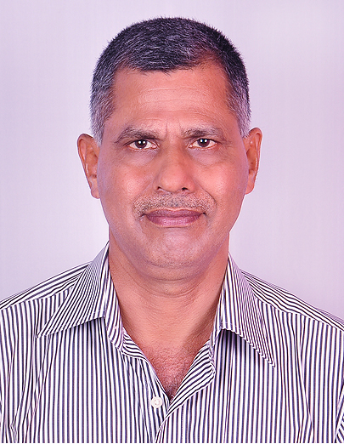 Coordinator

Dr Ganesh Bhat. S.
Research Professor
College of Management & Commerce

1. Purpose of ARC: The Centre of Community-based Enterprises (CCBE) devotes itself for research on Community-based Enterprises that are used to be driven by local community for its socio-economic needs; the products of many CBEs were recognized worldwide as Geographical Indicator (GI) Products. Starting from Udupi Jasmine and Muttu Gulla Brinjal of Coastal Karnataka, Karnataka has many such GI products that needs elaborate study to strengthen them in the test of time.

2. Objective of ARC:
Main objective of this centre for research is to make the case analysis of CBEs under GI Products originated and registered in Karnataka. Many CBEs are agri-based, providing rural employments for decades and are regaining their economic status of yesteryears thru the initiatives of State and non-State actor. During the changed circumstances, there is a need for in-depth empirical study of CBEs for testing the theories developed by Western Scholars as well as development of Theories of Community-based Enterprises as Constructivist.

3. Description on Proposed Research:
The Proposed research tries to answer CBEs theoretically and through field studies to understand the real socio-economic potential. The questions are:
1. How can a community benefit from community based entrepreneurship?
2. What are the key success factors of these enterprises?
3. How can the lessons learnt from successful CBEs used elsewhere?

4. Expected Outcome:
During this period of globalization and industrialization, socio-economic development of communities raises a big challenge for development strategists. A viable approach and solution to development would be to induce the communities to become entrepreneurial themselves and revive already existing CBEs like Udupi Sarees or initiate ideas of CBE elsewhere (e.g., Bhatkal jasmine became Udupi jasmine).

5. List of the Team Members:
1. Dr Ganesh Bhat S, Research Professors of Srinivas University
2. Ms Dhanya, Research Scholar
3. Mr Srihari Vadavi, Research Scholar

6. List of Working Papers: Not yet published any Working papers

7. List of related Published Papers in Journals, Proceedings, Book Chapters, Magazines by this Group.
This group has not yet published any papers. However, the team member: Ms Dhanya is studying Community-based Tourism of Kerala and Mr Srihari Vadavi has picked up Ilakal Sarees of Bagalkot district of Karnataka State. Apart from it, the Coordinator has published the following papers before joining the University, thru the collaborative research work with Dr Famida Handy and Dr Ram Cnaan, the faculty members of University of Pennsylvania, USA(first two papers) and the 3rd one with Dr Robin Shinde and Dr Jayaprakash Rao, A J Institute of Management, Mangalore.
- “Jasmine Growers of Coastal Karnataka Grassroots Sustainable Community-Based Enterprise in India; International Journal: Entrepreneurship & Regional Development Vol. 23, Nos. 5-6, June 2011, 405-417.
- “You reap what you pick, Longstanding Community Economic Development among Jasmine Growers of Coastal Karnataka”; Journal of Enterprising Communities: People and Places in Economy, 2014, Vol. 8 No. 2, pp. 86-102.
- Sustainable Community-based Enterprises: A Study of Udupi Jasmine, Anveshna, Vol.3, No.1, Jan-June 2013.

Name & Signature of Coordinator with date

